**Project Name:** Resume Selection

**Github Link:** https://github.com/projectsforstudents2022/Resume-Selection.git

**Why was this project created?**

Companies use internet marketing, referrals, and manual screening for each hiring. The hiring team receives the gathered resumes after that there is no issue if there are one or two resumes, but it is very tough to sift through 1000's of resumes and choose the best one. It becomes very difficult for the recruiting teams to read the resume and choose the resume according to the criteria.

**What problem is it solving?**

The most important task for every company is selecting the best employees since doing so will enormously speed up the expansion of the company. Resume screening is another name for the process of choosing the best candidates for tasks, online coding competitions, and many other things. We wish to start the resume section project ourselves utilizing a machine learning method to address this issue.

**Entire explanation of project**

* **PROPOSED APPROACH**

Our project's GUI (Graphical User Interface) focuses on the user interface where users log in and upload links to their social media accounts as well as their resumes in any format (pdf, doc, docx, etc.). A platform for user-database communication is provided by the GUI. It serves as a communicator and connector that links the database and facilitates data flow between the GUI and the database. The processing block is the one where our project is really processed. This block links the GUI to the database, serving as both a connector and a communicator to link the two together and facilitate data flow between the GUI and the database.

Its major purpose is to analyze information from resumes and social media profiles of candidates and store it in an organized style and database. This system will output utilizing a web application after saving the data. The layer used to store data is called the database tier. All the information required for processing the whole project is in this layer. The information in this layer relates to the student data that was gleaned from their resumes and social media sites.

Algorithm for creating next word prediction model :

**Step 1:** Import Libraries & Load Dataset

**Step 2:** Tokenization

**Step 3:** Stop Words Handling

**Step 4:** Build Naive Bayes Model

**Step 5:** Train Model

**Step 6:** Testing & Visualization

* **DATA FLOW DIAGRAM**

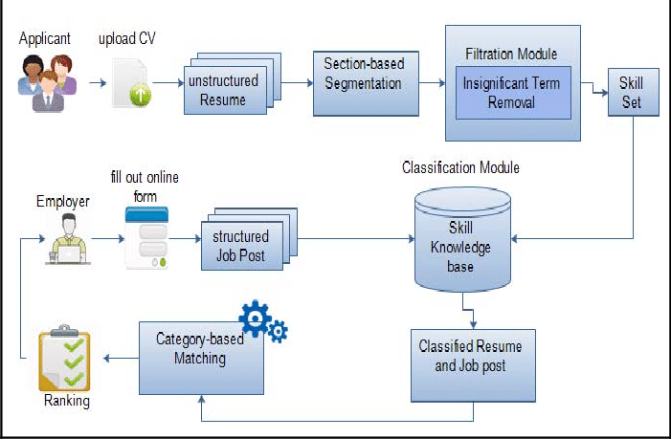

* **RESULT**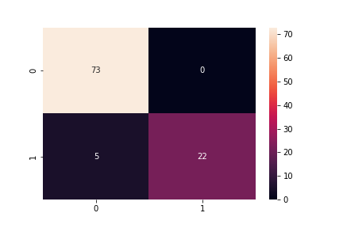
* **CONCLUSION**

Our technology will offer a more effective and efficient replacement for the present hiring procedure. This will introduce possible candidates to the company, and the applicant will be hired by a company that values his or her skill set and abilities. Through the example of resume screening, we saw how machine learning and Natural Language Processing may be used to enhance our daily lives. We recently categorized approximately 1000 resumes into their appropriate groups with 92% accuracy.